CS330 Programming Assignment 1: Ashya Singh

* The reason I am resubmitting my analysis part is because excel just kept on crashing last week and would not let me do any of the probability distributions or histograms correctly. I have the correct infection probability distributions for each of the input graphs sorted by p value but sadly, excel crashed every single day for the past week when I was trying to do the histograms. I understand that I must plot the average day input file on the x axis and count the number of nodes infected on day 1 through 100 for each p value for each graph. I had it all done for grid 1 and grid 4 multiple times this week but I guess my 6 year old laptop just couldn’t handle me running eclipse, terminal, excel, Ubuntu Linux, and everything else at once for the past two weeks and it just did not allow me to even get past these two graphs. The amount of times I imported my input files into excel and start creating my probability distributions and histograms for it to unexpectedly quit is countless. Here are the graphs I can make and whatever analysis I can do based on this information and other information I remember from my disappearing histograms.

My probability distributions, analysis on them, and analysis of the average day infected is shown below.

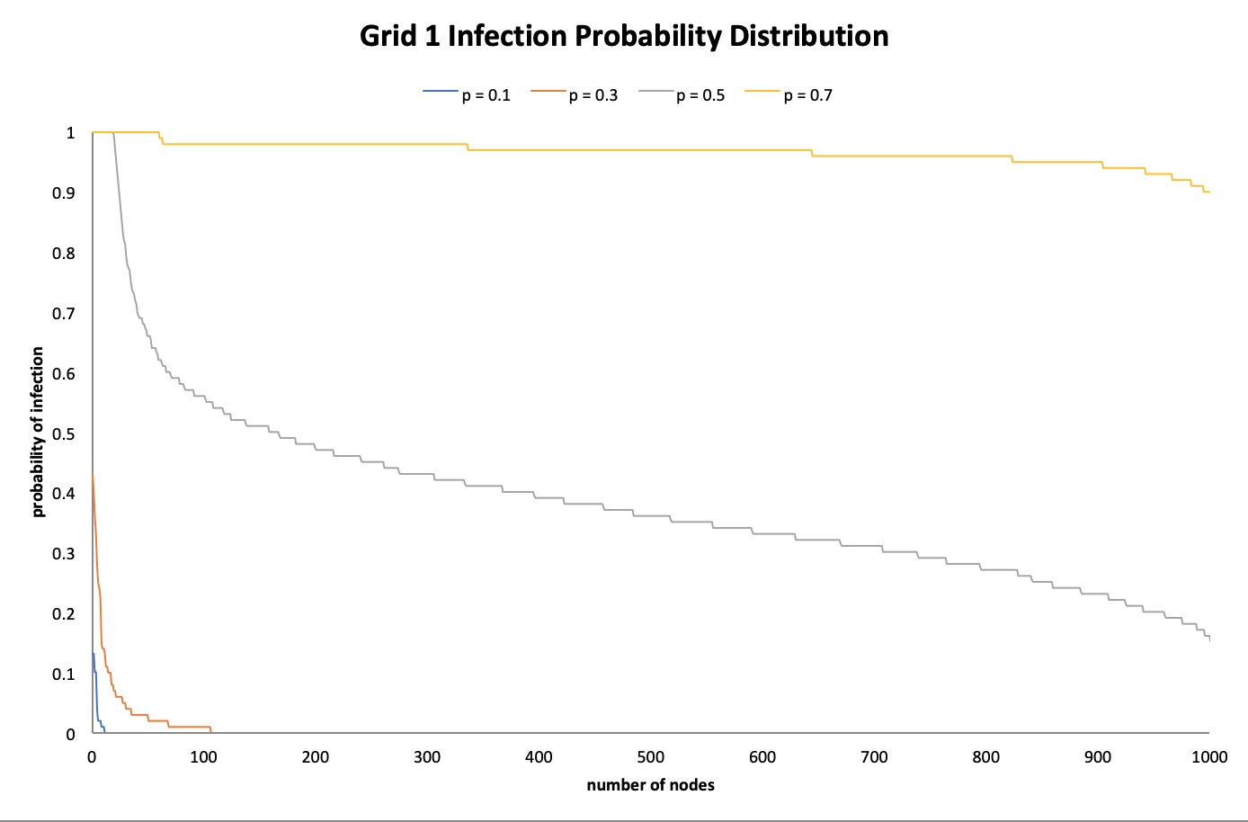

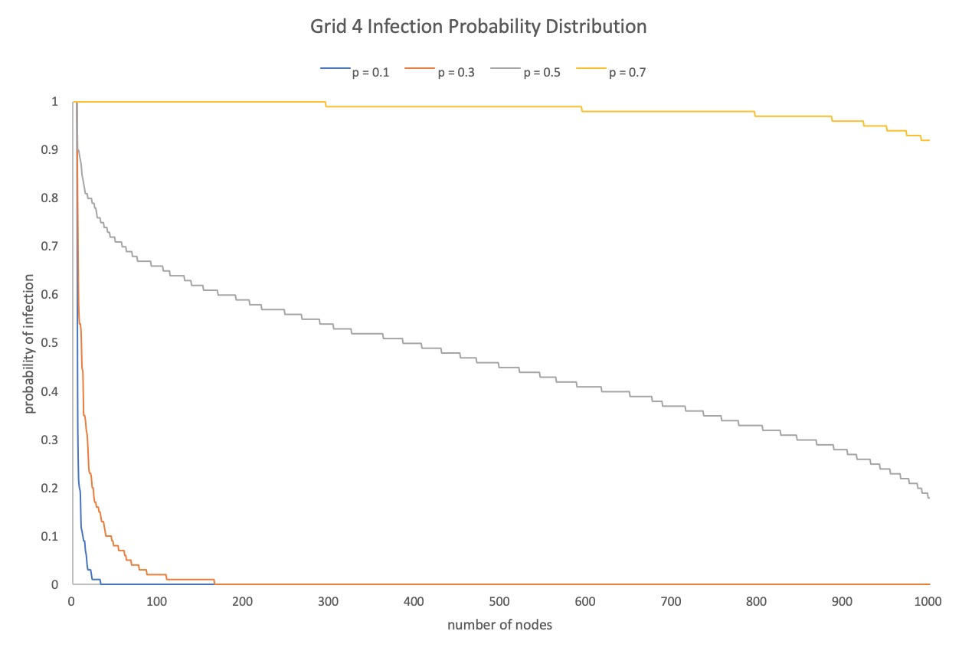

Grid 1 and Grid 4 (Graph 1 and Graph 4) analysis

The infection probability distributions for both of these graphs are incredibly similar which makes sense since the probability of infection output list for both of them were also very similar.

For p = 0.1, the probability of infection goes down to 0 before it even hits 100 nodes for both grid 1 and grid 4.

For p = 0.3, the probability of infection also goes down to 0 but this is after 100 and closer to 200 nodes for grid 1 and grid 4.

For p = 0.5, the probability of infection goes down pretty steadily from throughout starting at 100% and going down to around 20%.

For p = 0.7, the probability of infection stays close or is 100% for a majority of the nodes and only slowly starts going down.

This makes sense since the p values are slowly increasing from 10%, 30%, 50%, and 70% and the higher the infection probability in general, the higher the probability of any node getting infected.

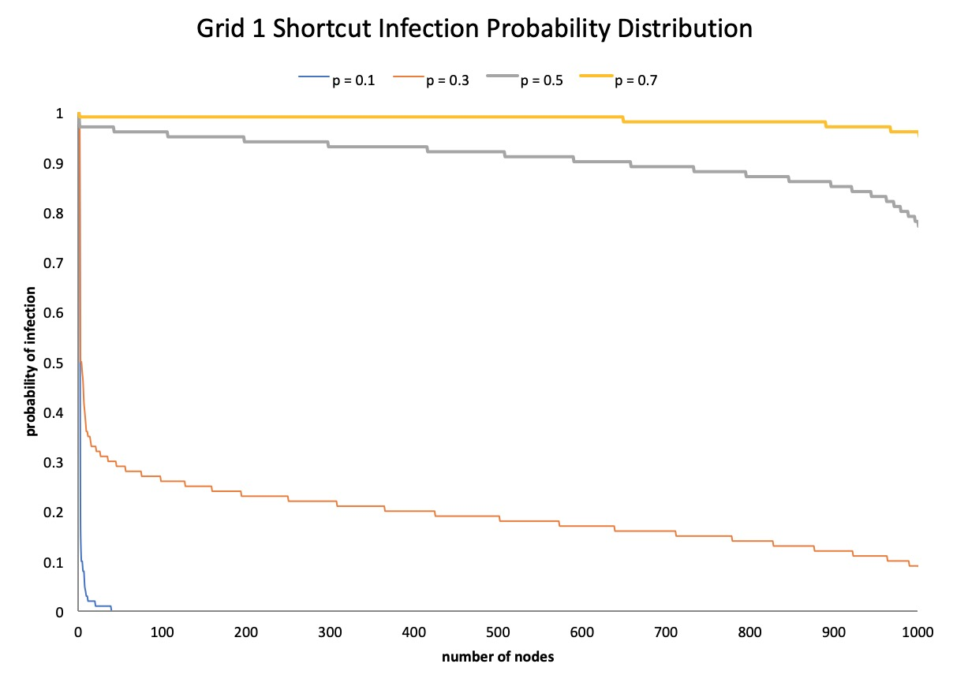

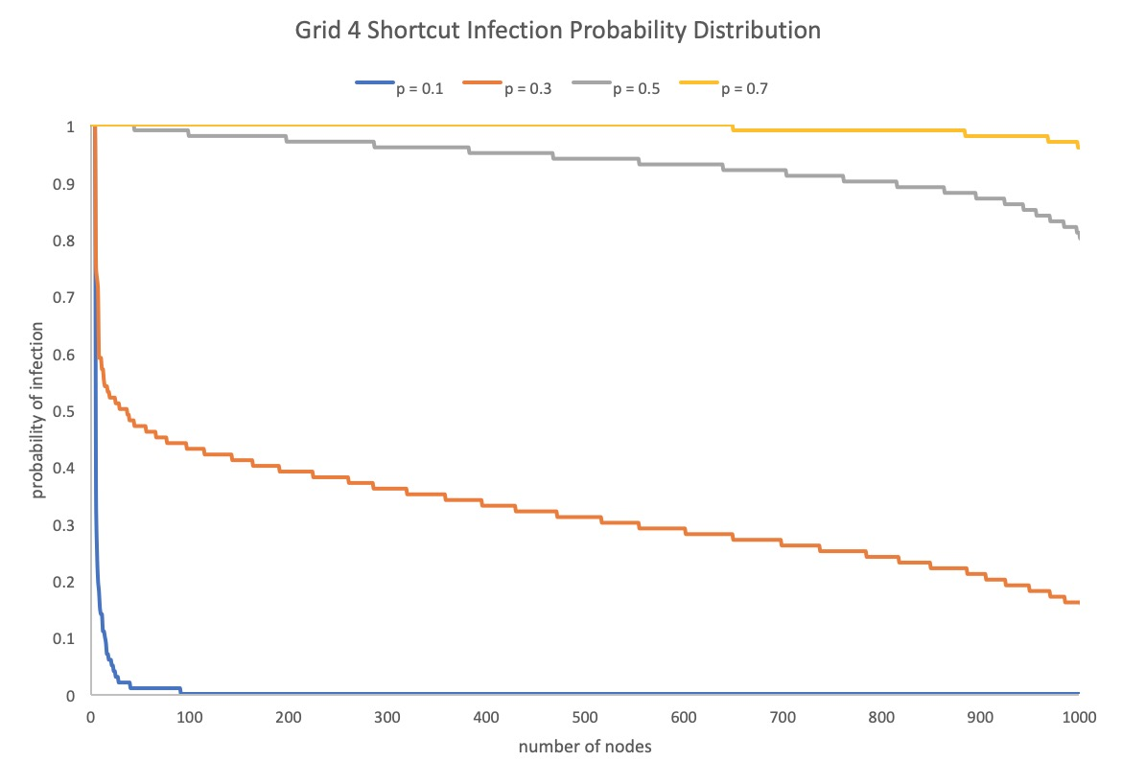

Grid 1 Shortcut and Grid 4 Shortcut (Graph 1 SC and Graph 4 SC) analysis

The infection probability distributions for both of these graphs are incredibly similar which makes sense since the probability of infection output list for both of them were also very similar.

For p = 0.1, the probability of infection goes down to 0 before it even hits 100 nodes for both grid 1 and grid 4.

For p = 0.3, the probability of infection goes down to about 50-60% and then decreases steadily until 10-20% for both graphs.

For p = 0.5, the probability of infection stays close or is 100% for a majority of the nodes and only slowly starts going down and the same goes for p = 0.7.

Again, makes sense since the p values are slowly increasing from 10%, 30%, 50%, and 70% and the higher the infection probability in general, the higher the probability of any node getting infected.

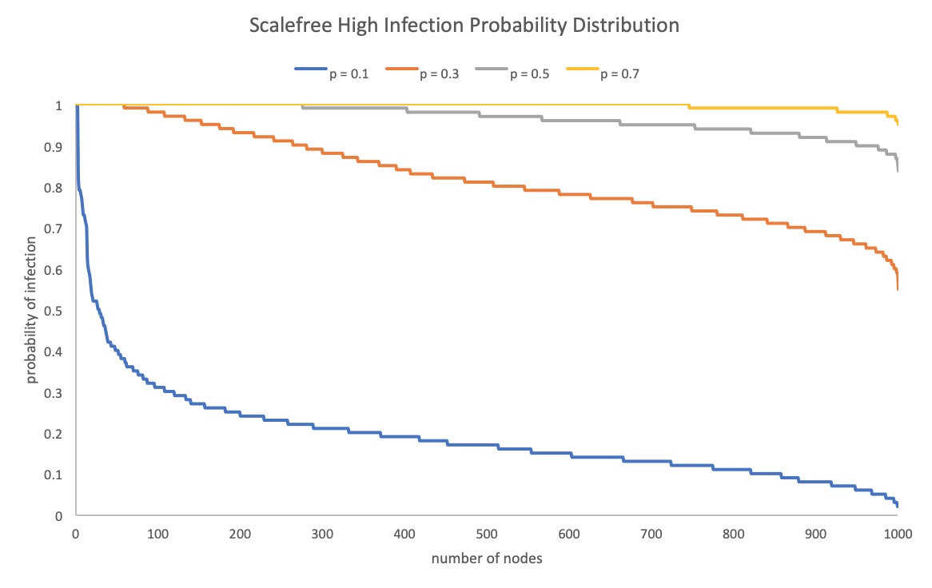

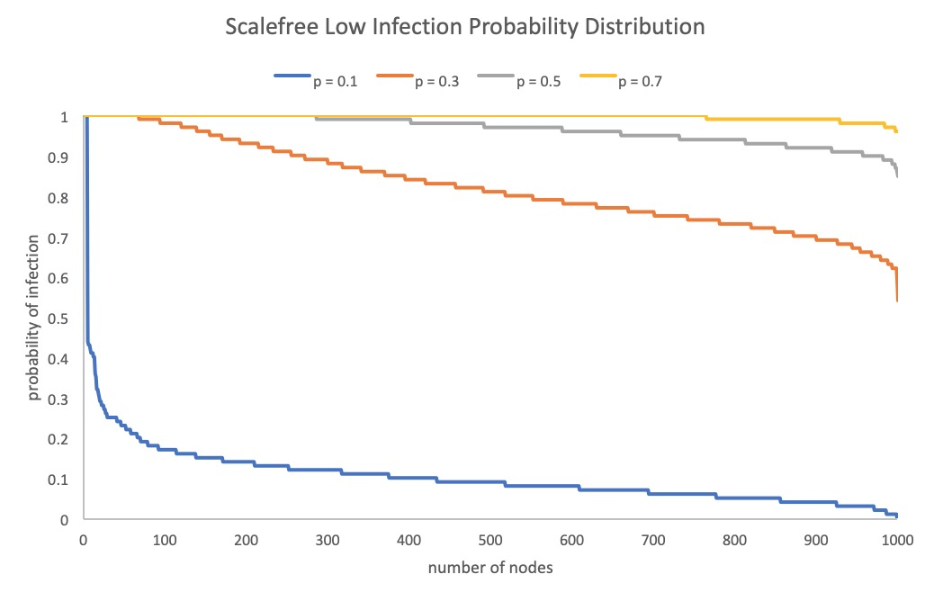

Scale free High and Scale free Low analysis

The infection probability distributions for both of these graphs are incredibly similar which makes sense since the probability of infection output list for both of them were also very similar.

For p = 0.1, the probability of infection goes down to pretty fast and then slowly decreases staying in the lower percentile range throughout all for both inputs.

For p = 0.3, the probability of infection stays high but decreases steadily to about 60-70% for both inputs.

For p = 0.5, the probability of infection still stays high and decreases to about 90% for both inputs.

For p = 0.7, the probability of infection stays close to 100% throughout all for both inputs.

This makes sense since the p values are slowly increasing from 10%, 30%, 50%, and 70% and the higher the infection probability in general, the higher the probability of any node getting infected.

Average Day Infected Analysis

The pattern is the same throughout all of the inputs, the higher your p value so your probability of getting infected, the more people get infected on each day. For my grid 1 histogram, I had a couple people infected on day 1 and day 2 for p = 0.1 and then for 0.3, 0.5, 0.7, more and more people started getting infected from days 1 to 40. It’s going to follow this same pattern for Grid 1, Grid 4, Grid 1 shortcut, Grid 4 shortcut. For Scale High and Scale Low, it will be more people infected on every one of the days since their infection probability distribution is so high and evenly spread. If the infection probability distribution has a higher percentage of people infected with the virus, then there will be more people infected on said day.